AI Enabled Smart Agriculture Using IoT and MQTT with Fuzzy Irrigation Control and Exploratory Crop Recommendation
Rishit Chaudhary¹*, Siddharth Verma¹, Syamasudha Veeragandham¹
¹School of Computer Science and Engineering, Vellore Institute of Technology, Vellore, Tamil Nadu, India 632014
Email: rishit.chaudhary2023@vitstudent.ac.in, siddharth.verma2023@vitstudent.ac.in, syamasudha.v@vit.ac.in
*Corresponding author

Abstract
This paper presents an ESP32 smart-agriculture prototype and a reproducible software simulation of local fuzzy irrigation control, telemetry reception and an exploratory crop classifier. The simulator executes a fully specified 27-rule zero-order Sugeno controller and a moisture-threshold reference on identical prescribed inputs. Nine 120-second scenarios cover normal, dry, wet, boundary, wet-step, sensor-fault, transport-outage, noisy-sensor and drying conditions. A five-sample filter, timed logical pump output, raw-wet shutdown and latest-snapshot transport surrogate are exposed through browser replay. Seventeen functional checks pass, and Python decisions agree with the supplied C++ controller at 1,150 tested input points within 0.00002 command minutes. The separate Random Forest experiment uses a stratified 1,760/440 training/test split of 2,200 public dataset records, with training-only proxy normalization. Held-out top-one accuracy is 94.32%, macro F1 is 0.943 and top-three accuracy is 100.00%; these are dataset results rather than sensor-domain or agronomic validation. All new operational results use synthetic inputs and accelerated logical timers. No measured irrigation volume, physical timing, yield improvement or field readiness is established. The physical DHT11 breadboard, DHT22 Wokwi counterpart and browser software model are distinguished throughout.
Keywords: Smart Agriculture, Internet of Things, MQTT, Fuzzy Logic, Random Forest, Crop Recommendation, Simulation, Edge Computing

1. Introduction
Sensor-based agriculture can support irrigation and crop planning by making environmental conditions observable and retaining a record for subsequent decisions. Reviews of agricultural machine learning identify applications in crop, water, and soil management, while emphasizing the importance of suitable data and evaluation [1]. This study investigates a small IoT prototype that combines local irrigation logic with a monitoring and advisory interface.
Soil moisture, air temperature, and relative humidity provide useful context for irrigation. Soil moisture is directly related to local water availability; temperature and humidity influence atmospheric demand. These measurements alone do not determine crop water requirements, which also depend on soil properties, rooting depth, crop stage, and weather. An ESP32 drip-irrigation study by Pereira et al. illustrates how sensing, actuation, and a user interface can be combined and tested on plants [2].
The motivation is to explore a system that can be assembled from accessible development boards and sensors and inspected through a simple dashboard. Affordability is a design objective rather than a measured result: the present study provides no procurement-backed bill of materials, total deployment cost, or economic comparison.
The architecture separates time-sensitive edge decisions from application-layer services. Local control can, in principle, continue when remote telemetry is unavailable, while a collector and dashboard retain observations and present advisory outputs. TerraGrow already demonstrates ESP32-based local fuzzy control with physical testing [4]; therefore, local fuzzy irrigation itself is not claimed as a new contribution.
Fixed timers and single-moisture thresholds are useful reference policies because their decisions are simple to reproduce. Their limitations depend on the application, sensor placement, threshold choice, and irrigation hardware. A multivariable fuzzy controller can express gradual responses, but improved water use or crop growth must be demonstrated through comparable experiments rather than inferred from the choice of controller.
The evaluated simulator uses minimum antecedent firing across a complete 27-rule table and a weighted average of constant rule consequents. This is a zero-order Sugeno controller [8]. It replaces the earlier incompletely specified seven-clause demonstration for the experiments reported here; the new specification and numerical outputs should not be treated as reproductions of the undocumented legacy observations.
Crop recommendation is a separate supervised-learning task. Senapaty et al. evaluate classifiers using historical crop data with a regional focus [3], while Cartolano et al. analyze seven-feature crop classification with SHAP and LIME [5]. Results from those datasets do not establish that a model will perform adequately when fed a smaller set of local sensor measurements.
Explainability is relevant to agricultural decision support, but this prototype does not yet demonstrate SHAP explanations or a farmer trust evaluation. The paper therefore treats SHAP [7] as a planned extension rather than an achieved contribution. The implemented dashboard assistant uses deterministic keyword rules and is described separately from model explainability.
The software tests explicitly inject invalid-sensor and transport-outage conditions and record their effects on local control and received snapshots. These deterministic checks establish selected program behaviours, not long-term reliability, hydraulic safety or robustness to field sensor degradation.
Section 2 reviews relevant work and narrows the research gap. Section 3 describes the architecture, datasets, control equations, and software. Section 4 reports simulation observations and their evidential limits. Section 5 identifies the experiments and integration changes required before field evaluation, and Section 6 concludes the paper.

1.1 Research Objectives
1) To specify an ESP32 sensing node and demonstrate temperature, humidity, and a normalized moisture input in simulation, with a documented sampling interval and moving-average filter.
2) To describe local singleton-output fuzzy irrigation logic and examine selected normal, boundary, and fault conditions without claiming agronomic optimization.
3) To connect MQTT collection, persistent telemetry, and a Streamlit dashboard, while separating the exploratory public-dataset crop model from validated sensor-based recommendations.
4) To archive reproducible synthetic trajectories, compare fuzzy and threshold policies on the same input, verify selected safety and transport behaviours, and distinguish software results from the physical tests still required.

2. Related Work
Liakos et al. [1] review machine-learning applications across crop, water, and soil management. Their synthesis supports combining observations with decision support, but does not provide a performance baseline for this particular prototype. Different measurement protocols and outcome definitions prevent direct transfer of accuracy or efficiency percentages between systems.
Pereira et al. [2] describe an ESP32-based drip-irrigation system with soil and environmental sensing, a flow sensor, solenoid control, and a Blynk interface. Their study includes primary and field testing involving green onions. This is stronger evidence of physical operation than a potentiometer-based simulation and provides a relevant comparison for the hardware-validation stage still required here.
Wijayakusuma et al. [4] present TerraGrow, an ESP32 platform that performs local multi-sensor Sugeno fuzzy irrigation and provides reproducible design information. Its bench and greenhouse evaluation shows that local fuzzy control and accessible IoT hardware have already been investigated. The present work consequently focuses on an educational integration and its verification limits, rather than claiming the first autonomous fuzzy irrigation architecture.
MQTT provides a publish–subscribe transport with defined session and quality-of-service semantics [9]. Selecting MQTT does not by itself establish low latency, authenticated delivery, or offline buffering. The effective service depends on the publisher, subscription, broker, transport security, and application logic. The collector in this project enables TLS by default, whereas the reported Wokwi demonstration used a separate plain-MQTT configuration.
Protocol performance must be assessed with timestamps, message identifiers, clock assumptions, and a defined observation interval. A subscriber receiving an example payload establishes communication functionality, not a packet-delivery ratio or a round-trip-latency distribution. This study therefore avoids transferring communication percentages reported by other systems to its own results.
Senapaty et al. [3] compare multiple crop classifiers using regional agricultural data and discuss the effect of balancing and preprocessing. Breiman’s Random Forest method [6] is a suitable tabular classification approach, but estimator selection does not resolve differences between training features and deployed measurements. The present repository contains a reduced-feature model using a rainfall–humidity moisture proxy, which requires separate agronomic and sensor-domain validation [15].
Cartolano et al. [5] demonstrate SHAP and LIME on a crop-recommendation dataset with nitrogen, phosphorus, potassium, temperature, humidity, pH, and rainfall. Their explanation plots show why a prediction was produced within that dataset. SHAP assigns feature contributions to a particular model output [7]; it does not establish causation, sensor accuracy, or agronomic correctness. No explanation output is reported for the present prototype.
These studies establish that IoT sensing, local fuzzy control, crop classification, and model explanations are existing capabilities. The unresolved question for this prototype is whether its telemetry schema, sensor definitions, control policy, and advisory model can be made consistent and then evaluated on labeled physical observations. Table 1 relates the reviewed evidence to that narrower scope.

Table 1: Verified Prior Work and Relationship to This Prototype
Ref. | Focus | Verified contribution | Relationship and limitation
[1] | Agricultural ML review | Reviews crop, water, and soil applications | Motivates decision support; no transferable prototype metric
[2] | ESP32 drip irrigation | Sensor/valve/Blynk system with plant testing | Physical-test reference; this study remains simulation-only
[4] | Local fuzzy control | TerraGrow ESP32 fuzzy irrigation with bench/greenhouse tests | Local autonomy is prior work, not claimed novelty
[9] | MQTT specification | Defines publish–subscribe and QoS semantics | Transport choice does not prove latency or delivery rate
[3] | Regional crop advisory | Compares classifiers on regional crop records | Highlights need for relevant labels and a defined evaluation
[5], [7] | Crop XAI and SHAP | Dataset-based model explanations and feature attribution | SHAP is future work here; no user-trust improvement measured
[15] | This prototype | Collector, Streamlit, proxy-feature RF scripts | Integration and functional scope only; no cost or yield claim

Research Gap and Scope
- Integration gap: the prototype must preserve sensor meaning, units, and field names from acquisition through storage and inference; an assembled pipeline alone does not demonstrate this consistency.
- Model-transfer gap: rainfall-derived training proxies have not been calibrated to the capacitive soil sensor, and ambient DHT temperature has not been shown to represent soil temperature.
- Control-evaluation gap: same-input software comparisons can establish policy differences, but advantages in irrigation volume, energy or crop growth still require calibrated sensors, matched physical trials and measured outcomes.
- Reliability gap: deterministic fault and outage traces test specified program behaviour but do not characterize field failure rates, timing variability or multi-device network operation.
- Evidence gap: physical measurements, broader model comparisons, proxy-to-sensor calibration, SHAP outputs, user testing and procurement costs remain necessary before claiming agronomic effectiveness, trust or affordability.

Problem Statement
The problem addressed is the construction and reproducible functional evaluation of a sensing-control-telemetry prototype, while identifying the evidence still needed for field decision support. The study specifies its controller, runs identical synthetic input traces through two policies, records failure handling and evaluates a separate dataset classifier. It does not claim to close the physical-validation and model-transfer gaps identified in prior work.

3. Materials and Methods

3.1 System Overview and Three-Layer Architecture
The architecture comprises an ESP32 sensing design, an MQTT collector and a Streamlit application, with a separate local browser simulation used for the new operational experiments. The physical assembly in Figure 3 uses a DHT11 and capacitive probe; the Wokwi illustration in Figure 4 uses a DHT22 surrogate and a potentiometer. The browser engine executes in Python and does not emulate ESP32 instruction timing or the DHT electrical protocol. Prescribed moisture, air temperature and relative humidity are sampled every five software seconds and filtered before control. A logical pump indicator replaces hydraulic actuation.
The repository application supports MQTT collection and weather enrichment [15]. The bundled Wokwi counterpart publishes synthetic demonstration telemetry on smartagri/23bct0157/demo-v1/data using plain MQTT port 1883, whereas the original collector defaults to smartagri/data and TLS port 8883. Those settings must be made compatible when connecting the two. The browser experiments use an in-process online/offline transport surrogate instead of a real broker; they therefore make no new claim about MQTT encryption, packet latency, quality of service or delivery reliability.
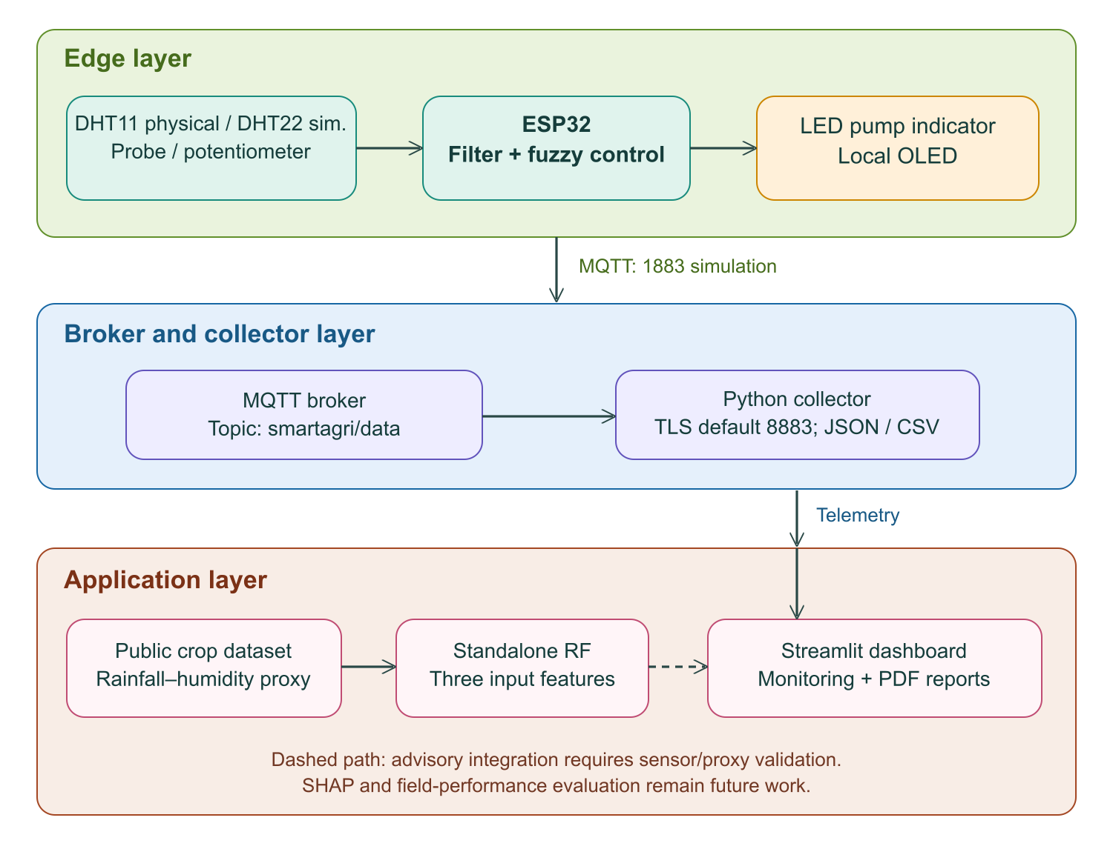

Figure 1: Three-Layer Architecture and Separate Crop-Model Data Path
The application uses Streamlit, scikit-learn and ReportLab [15]. The new standalone simulator retains a separate crop experiment with 200 Random Forest trees, maximum depth 12, minimum leaf size 3 and seed 42, inside a fitted StandardScaler pipeline. Temperature, humidity and an engineered rainfall-humidity moisture proxy form its three inputs. The stratified holdout and saved metrics are described in Sections 3.3 and 4.5. Equal feature count does not validate the equivalence of a physical moisture reading and the training proxy. SHAP is not implemented.

3.2 Circuit Diagram and Pin Mapping
Table 2 distinguishes the physical sensors and firmware signals from their software substitutes. Figure 2 remains a schematic of the sensing and LED connections. DHT11 and DHT22 require matching firmware sensor types [10], [12]. The browser schematic is a visualization of computed state rather than a circuit-level electrical simulation.
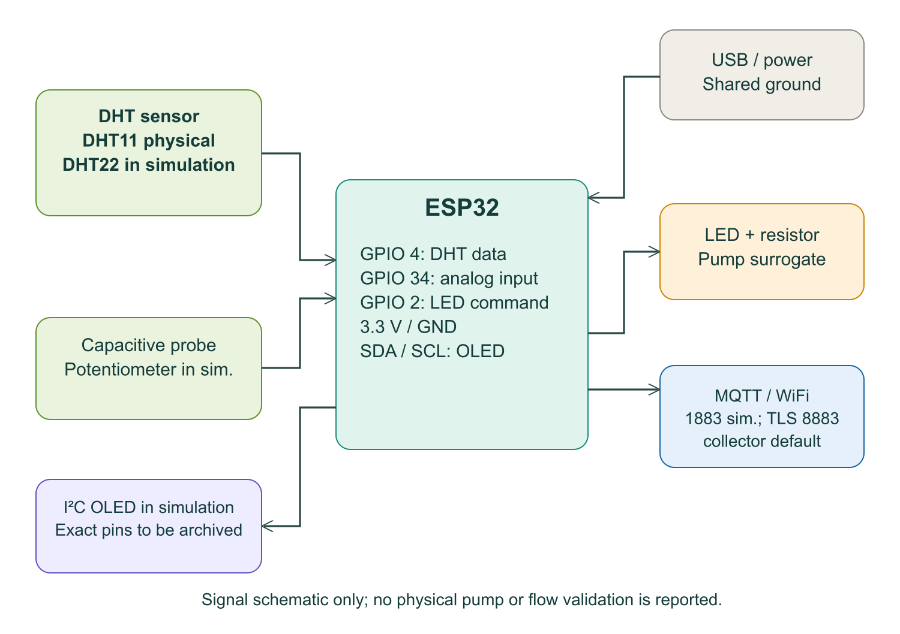
Figure 2: Schematic Sensor and LED Connections for the ESP32 Node
Table 2: Edge Signal Assignments and Configuration Differences
Component | ESP32 Pin | Signal / Interface | Configuration
DHT temperature / humidity | GPIO 4 | Digital sensor data | DHT11 physical; DHT22 in shown simulation
Moisture input | GPIO 34 (ADC1_CH6) | Analog input, 12-bit nominal | Physical capacitive probe; simulated potentiometer
SSD1306 OLED | GPIO 21 / GPIO 22 | I²C in Figure 4 | Bundled I2C firmware; browser renders computed state
LED + 220 Ω resistor | GPIO 2 | Digital ON/OFF indicator | Pump surrogate; no driver or hydraulic test
WiFi / MQTT | On-board WiFi | MQTT in firmware; local surrogate in browser | 1883 reported simulation; collector TLS default 8883
The bundled Wokwi firmware specifies an I2C SSD1306 at address 0x3C, SDA GPIO 21 and SCL GPIO 22, alongside its diagram and library list. This is consistent with the display interface described by Wokwi [11]. The current browser experiments do not establish a fresh Wokwi build or hardware display operation.
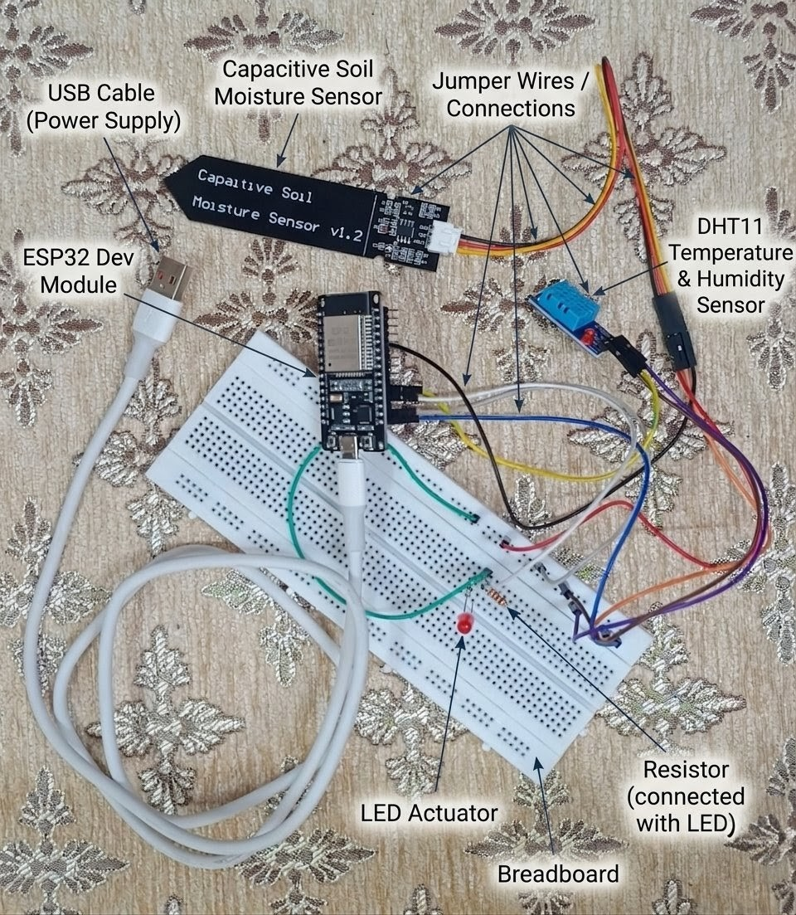
Figure 3: Physical DHT11 Breadboard Assembly Not Used for the Reported Test Cases

3.3 Dataset and Data Collection
Operational results and crop labels come from separate sources. The controller experiments use nine prescribed synthetic traces with complete numerical exports; they contain no crop labels or measured soil-water ground truth. The crop experiment reads the repository CSV with N, P, K, temperature, humidity, ph, rainfall and label, corresponding to the published dataset schema [14], [15]. Its 2,200 records contain 22 balanced labels. The exact CSV is identified by SHA256 54a5a6e5408668e668667efc50de2fc867c1b875e0431b4f54dd331b0a109a4e. Its original collection and download provenance remains a limitation.
Table 3: Operational and Crop Dataset Specifications
Field | Specification and evidence status
Operational source | Nine deterministic synthetic traces, 120 software seconds each; one execution per scenario
Sampling and filtering | 5-second samples, one-second state clock, mean of up to five valid samples; filter cleared on fault
Inputs | Prescribed moisture (%), ambient air temperature (C), relative humidity (% RH); not soil-water ground truth
Output | Logical command minutes and timed output; 1 command min = 1 software s; no measured flow
Persistence | Each run saves JSON and per-second CSV; offline transport retains only one pending snapshot
Crop data | 2,200 labeled CSV records, 22 balanced classes; dataset SHA256 archived
RF features | Temperature, humidity and normalized proxy 0.6 rainfall + 0.4 humidity
Training and test | Stratified seed-42 split: 1,760 training / 440 test; normalization and scaler fit on training rows only
Evaluation scope | Single dataset holdout; no physical feature transfer, field labels or cross-validation claim

3.4 Mathematical Model and Singleton Fuzzy Controller
The evaluated controller is a fully specified 27-rule zero-order Sugeno system. For each moisture, air-temperature and humidity category combination, the firing strength is the minimum of the three membership degrees. Every rule has its own constant duration consequence. The output is the weighted mean of all active rule consequences; category-wise maximum aggregation from the earlier seven-clause design is not used in these experiments [8]. Appendix A lists all 27 consequences compactly.
Triangular memberships use the expression below for a < b < c. Left shoulders are clamp((b - x)/(b - a), 0, 1); right shoulders are clamp((x - a)/(b - a), 0, 1). These definitions cover the domain endpoints without repeated triangle vertices.
μ(x; a, b, c) = max(0, min((x − a)/(b − a), (c − x)/(c − b)))
Table 4: Fuzzy Variables and Output Singletons
Variable | Linguistic sets | Evaluated domain and membership parameters
Moisture (%) | Dry, Normal, Wet | Domain 0-100; shoulders 20-50 / 50-80; triangle 20/50/80
Air temperature (C) | Cool, Warm, Hot | Domain 0-50; shoulders 15-27 / 27-39; triangle 15/27/39
Humidity (% RH) | Low, Medium, High | Domain 0-100; shoulders 30-60 / 60-90; triangle 30/60/90
Command (min) | 27 rule consequents | All constants in Appendix A; weighted output 0-40; timer acceleration 1 s per command minute
Moisture uses a dry left shoulder from 20 to 50%, a normal triangle at 20/50/80%, and a wet right shoulder from 50 to 80%. Air temperature uses a cool left shoulder from 15 to 27 C, a warm triangle at 15/27/39 C, and a hot right shoulder from 27 to 39 C. Humidity uses a low shoulder at 30 to 60%, a medium triangle at 30/60/90%, and a high shoulder at 60 to 90%.
- For rule r, let i, j and k identify its moisture, temperature and humidity categories. Its firing strength is w_r = min(mu_Mi, mu_Tj, mu_Hk).
- All 27 consequents c_r are given in Appendix A. They range from 0 to 40 command minutes and are explicit controller design choices, not crop-specific irrigation recommendations.
- The total firing strength is W = sum from r = 1 to 27 of w_r. Valid inputs have positive coverage under the stated shoulder and triangular memberships.
- For W > 0, y = (sum from r = 1 to 27 of w_r c_r) / W. Invalid input or zero coverage produces an explicit invalid state, zero command and an off output.
Input acceptance is finite moisture 0-100%, air temperature 0-50 C and relative humidity 0-100%. These are controller test bounds, not measured sensor specifications.
The nonnegative weighted mean remains within 0-40 command minutes. The low-moisture alert uses raw moisture <=30%; the comparator uses filtered moisture <30%.
The Python inference function is checked against the supplied C++ controller on 1,000 seed-42 random inputs and 150 boundary combinations. Agreement is accepted within 0.00002 minutes to allow floating-point differences. The test bench also checks all 27 rule peaks, selected boundaries, invalid values and filter response. This is selected numerical verification, not an exhaustive proof for every real-valued input.

3.5 Threshold Reference and Timed Output Logic
The threshold reference issues 10 command minutes when filtered moisture is strictly below 30%, and zero otherwise. Both controllers receive the same filtered observation, validity gate, raw-wet stop and dose-window schedule. A raw <=30% alert is distinct from this strict actuator threshold; exactly 30% therefore triggers the alert but produces no reference dose.
The simulator samples at five-second intervals and averages up to five valid samples. An initial dose and subsequent 60-second windows can start the current command. One command minute lasts one software second: a 40-minute command is displayed as 40 accelerated simulation seconds. Raw moisture >=80% or a zero command stops an active dose at the next sample. An injected sensor fault stops both outputs on its one-second software tick, clears the filter and sets command zero. Fault recovery resumes at the next five-second sample. The Wokwi firmware can request an immediate recovery sample, so recovery schedules are not cycle-equivalent.
Pump-on time is counted over [0, 120) seconds; the visible endpoint at 120 seconds may begin the next dose but is excluded from the interval summary. The output does not alter the prescribed moisture trace. No calibrated evapotranspiration, hydraulic flow or soil-water balance is implemented, so differences between command times do not establish water-use efficiency or controller superiority.

3.6 System Algorithm
Algorithm 1 Software Simulation and Separate Crop Evaluation
1) Select one of nine scenarios or explicit finite inputs; record the duration, seed, noise amplitude and scenario identifier.
2) Generate prescribed moisture, air-temperature and humidity observations, sampled every five seconds on a one-second software clock.
3) Apply fault injection, reject invalid observations, and maintain the mean of up to five valid samples. Clear the filter on a fault.
4) Compute all 27 minimum-firing strengths and their weighted singleton output; separately evaluate the strict 30% reference on the identical filtered input.
5) Apply the timed-dose window, invalid-input gate and raw-wet shutdown to each logical output independently.
6) Retain per-second states, samples, membership strengths, rules, remaining dose time and local events for replay and export.
7) Deliver the latest pending snapshot while the transport surrogate is online. During an outage retain one pending snapshot, overwriting older unsent values; the collector keeps its previous received record.
8) Save run JSON, trace CSV and unique run IDs. Run the 17-check regression bench and a separate C++ numerical equivalence test.
9) For the crop experiment, split labeled data first, fit proxy normalization and the model using training records only, then evaluate the untouched 440-record holdout.
10) Display the calculated traces and optional crop scores in the local browser. Retain screenshots with their replay times and run IDs. Main-dashboard MQTT collection is a separate application path.

3.7 Hardware and Software Stack
Table 5: Hardware and Software Stack
Layer | Technology | Role and qualification
Controller | ESP32 DevKit v1 | WiFi/ADC and local control design; no field reliability result
Environmental sensor | DHT11 physical / DHT22 simulated | DHT11 nominal ±2°C, ±5%RH; 0–50°C and 20–80%RH per cited guide [12]. Not measured accuracy
Moisture input | Capacitive probe / potentiometer | Probe requires soil-specific calibration; potentiometer does not reproduce noise or degradation
Firmware | C++ / Arduino-style ESP32 design | Supplied C++ controller/diagram plus Python software twin; no new physical build verification
MQTT client | Paho-MQTT collector | TLS enabled, port 8883 default; publisher QoS not verified
Broker | HiveMQ MQTT service | Separate plain-MQTT simulation configuration reported; no delivery/buffering guarantee measured
Collector | Python + JSON / CSV | Weather enrichment and persistence; no strict field/range schema validation
ML engine | scikit-learn Random Forest pipeline | 200 trees, depth 12, minimum leaf 3; standalone proxy-feature model
Explainability | SHAP planned | No SHAP call, plot, or user study in inspected implementation
Dashboard | Streamlit | Readings, charts, class scores, rule-based assistant; no React application evidenced
Reporting | ReportLab | PDF export capability; no agronomic effectiveness claim

4. Experimental Results and Discussion

4.1 Experimental Conditions
Nine deterministic scenarios were executed using the released Python software engine, each with a 120-second trace and seed 7. A sample occurs every five seconds; state and fault gating advance in one-second steps. There is one execution per prescribed scenario, not an independently replicated field-trial dataset. Uniform bounded moisture noise is enabled for TC-08. Screenshots in Appendix B show actual browser-rendered states, with run IDs and clock values archived in paper-screenshots.json. The Wokwi image below documents the earlier circuit counterpart; the new results do not depend on an online Wokwi build or broker connection.
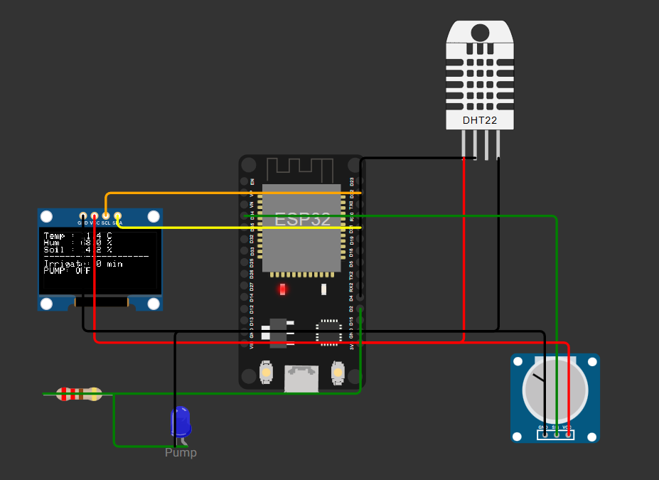
Figure 4: Earlier Wokwi Circuit Counterpart Not the Source of the New Browser Experiment Traces

4.2 Test Cases and Results
Table 6: Reproducible Synthetic Test Conditions and Observed Outputs
ID | Scenario | Prescribed condition | Observed selected state | Figure
TC-01 | Normal | 50%, 27 C, 60% RH | Fuzzy 8.00 min; reference 0; fuzzy OFF at 8 s | 5
TC-02 | Dry and hot | 10%, 45 C, 20% RH | Fuzzy 40.00 min; reference 10.00 min | 6
TC-03 | Wet | 85%, 27 C, 60% RH | Both zero; both outputs OFF | 7
TC-04 | Boundary | 30%, 27 C, 60% RH | Fuzzy 20.00 min; reference 0; alert active | 8
TC-05 | Wet step | 10 to 90% at 15 s; 45 C, 20% RH | At 15 s average 30%; fuzzy 34.00 min, output OFF | 9
TC-06 | Sensor fault | 10%, 45 C, 20% RH; fault [12,27) s | Zero and OFF during fault; fresh recovery sample at 30 s | 10
TC-07 | Offline | 10%, 45 C, 20% RH; offline [10,40) s | Local ON at 35 s; collector sample 5 s; new snapshot at 40 s | 11
TC-08 | Noisy input | 30%, 27 C, 60% RH; seed 7, uniform +/-10 pp | Repeatable noisy trace; moving average and output lanes saved | 12
TC-09 | Drying | 65 to 10% linear ramp over 120 s; 32 C, 45% RH | Identical ramp drives both policies; no plant feedback | 13
Table 6 records the complete prescribed conditions and selected observed states. The same trace drives both controllers. These outcomes replace the legacy 8.1-minute and 38.7-minute descriptions; no claim is made that the new rule base reproduces those undocumented values.
TC-01 produces an exact 8.00-minute fuzzy command at 50% moisture, 27 C and 60% RH, compared with zero for the reference. The fuzzy indicator is on at 7 seconds and off at 8 seconds. TC-02 at 10% / 45 C / 20% produces 40.00 versus 10.00 command minutes. These are accelerated logical doses, not measured water delivery.
TC-03 at 85% moisture produces zero in both policies. TC-04 at exactly 30% produces a 20.00-minute fuzzy command, zero reference command and an active low-moisture alert. Numerical checks also verify 29% and 31% reference behaviour and the 19.40-minute fuzzy result at 31% / 27 C / 60%.
TC-05 steps raw moisture from 10% to 90% at 15 seconds. The filtered value is still 30% and the fuzzy command is 34.00 minutes, but the raw-wet gate stops the current output immediately at that sampling tick. A nonzero inference result is therefore correctly distinguished from the applied output state.
TC-06 injects failure from 12 seconds until just before 27 seconds. Both commands become zero and both outputs remain off during the fault. The first valid scheduled sample at 30 seconds restarts a fresh filter and a new dose. This is a software fail-safe check; physical fault-detection and actuator timing are not measured.
TC-07 disables the transport surrogate from 10 to 40 seconds. Local fuzzy output remains on at 35 seconds, while the collector retains its 5-second snapshot, now 30 seconds old. At 40 seconds the latest snapshot is delivered. Six intermediate offline snapshots are overwritten in this trace; the result does not demonstrate lossless buffering or actual MQTT reconnection performance.
TC-08 supplies seeded uniform moisture noise of +/-10 percentage points around 30%, clamped to the valid range. The raw and five-sample traces are directly inspectable and repeated seed-7 runs are identical. TC-09 prescribes a 65-to-10% drying ramp. Its moisture is independent of output, so it tests policy response without claiming a closed-loop soil-water experiment.

4.3 Controller Comparison and Software Verification
Table 7: Observed Accelerated Pump On Time on Identical Inputs
Scenario | Fuzzy ON s | Reference ON s | Interpretation
normal | 16 | 0 | Accelerated logical time; no volume measurement
dry hot | 80 | 20 | Accelerated logical time; no volume measurement
wet | 0 | 0 | Accelerated logical time; no volume measurement
boundary | 40 | 0 | Accelerated logical time; no volume measurement
wet stop | 15 | 10 | Accelerated logical time; no volume measurement
sensor fault | 82 | 30 | Accelerated logical time; no volume measurement
network loss | 80 | 20 | Accelerated logical time; no volume measurement
noisy | 47 | 20 | Accelerated logical time; no volume measurement
drying | 28 | 0 | Accelerated logical time; no volume measurement

4.4 Telemetry and Fault Handling
The browser transport is explicitly simulated in process. A generated snapshot contains sequence, sample time, filtered readings, command and output state. The collector receives it while online and retains the previous record while offline. A one-snapshot pending queue overwrites older unsent records. Staleness is the software-clock difference between the current time and the saved sample time, with a stale label above 15 seconds. These checks establish this local program behaviour only; no network packets, broker latency, packet-delivery ratio, QoS or TLS property is measured. The separate repository collector/dashboard path remains a deployment integration task [15].

4.5 Dashboard and Independent Crop Experiment
Table 8: Interface and Dataset Evaluation Results
Function or metric | Observed implementation or result
Field replay | Computed schematic, filtered readings, independent output timers, fault status and collector age
Signal inspection | Raw and filtered moisture, output intervals, memberships, fired rules and events
Verification | 17/17 built-in checks; 8 automated tests pass; C++ agreement at 1,150 tested points
RF holdout accuracy | 94.32% top-one accuracy on 440 held-out records
RF macro F1 | 0.943; macro average across the 22 labels
RF top-three accuracy | 100.00%; labels in the three highest model scores
Software environment | Python 3.13.7, scikit-learn 1.8.0, pandas 2.3.3, NumPy 2.4.3
Export and evidence | Run JSON, trace CSV, suite JSON/CSV, source hashes and screenshot run IDs
Unmeasured outcomes | Usability, field crop suitability, water volume, energy, yield, physical latency and real MQTT performance
The local browser exposes four views: field replay, signals and rules, the test bench and crop evaluation. The separate Streamlit application provides accounts, history, alerts, a deterministic helper and reports. Neither interface has undergone a user study. The new Random Forest holdout experiment gives accuracy 94.32%, macro F1 0.943 and top-three accuracy 100.00% on 440 held-out records. Proxy normalization uses only the 1,760 training rows. The dataset and library versions are archived with the model. No cross-validation, probability calibration, physical sensor transfer test or SHAP output is claimed.

4.6 Safety and Timer Checks
The automatic bench reports 17 of 17 checks passed. It covers selected exact commands, the strict reference boundary, all 27 consequent peaks, invalid input, timer expiry, raw-wet shutdown, sensor recovery, offline local control, latest-snapshot reconnection, the five-sample step response and seed repeatability.
A separate C++ bridge compiles the actual controller.h and compares its fuzzy and reference output against Python at 1,150 input points. Eight automated tests pass, including that comparison, run configuration validation, seed changes, dose scheduling, safe wet-input shutdown, export round-trips and HTTP request checks. These counts describe the software test suite and are not independent experimental replications.
For a filled five-sample filter, a 100-to-0% step yields averages of 80, 60, 40, 20 and 0%. This verifies the implemented arithmetic response. Fault recovery clears the window before accepting new input. Such checks do not measure physical DHT response, probe calibration or real actuator stop latency.
The new implementation therefore demonstrates specified software safety and replay behaviour beyond the earlier skipped-cycle observations. It still does not establish safe electrical pump driving, durable offline storage, real network autonomy or sustained fault tolerance in a farm deployment.

4.7 Evidence Scope
Table 9: Outcomes Established and Remaining Validation
Aspect | Design expectation | Observed result | Remaining limit
Rule calculation | Reproduce specified outputs | 27 peaks and 1,150 C++ comparisons pass | Selected numerical tests, not exhaustive proof
Fault gate | Stop on invalid sensor state | Zero command and OFF during injected fault | No physical sensor or relay latency
Offline behaviour | Continue local timing | Local ON while collector snapshot becomes stale | Transport surrogate, not a broker benchmark
Policy comparison | Use identical input | Nine paired logical traces saved | No matched agronomic target or water flow
Crop classification | Untouched test partition | 94.32% accuracy; macro F1 0.943 | Single dataset and uncalibrated moisture proxy
Both controllers are evaluated on exactly the same synthetic input sequence; differences in their logical output can therefore be attributed to the stated policies and shared gating. The fuzzy controller does not necessarily use less output time: in the hot-dry trace it is on for 80 seconds versus 20 seconds for the reference. These policies have no matched agronomic target or measured water volume, so no water-saving percentage or superiority claim follows.

4.8 Threats to Validity
Internal validity is bounded by deterministic scripted inputs and selected software checks. The C++ comparison establishes agreement at the tested points, not an exhaustive proof or cycle-accurate ESP32 execution. Construct validity is limited because the moisture signal is prescribed, the pump is a logical output, command minutes are accelerated, and the transport is an in-process surrogate. External validity is limited by the absence of soil, plants, hydraulic hardware, seasonal conditions and multi-device field tests. A moving average changes response delay; simulated noise does not reproduce probe drift or electrical faults. The crop model uses a rainfall-humidity proxy and a single stratified holdout; collection provenance, geographical transfer, calibration and physical-input equivalence remain unresolved. No confidence interval or statistical significance is inferred from these deterministic scenarios.

5. Limitations and Future Work
The contribution is a documented prototype architecture and a reproducible software experiment. Source-defined rules, archived traces, paired controller inputs and an untouched dataset holdout improve reproducibility, while physical measurement and deployment limitations remain substantial.
First, the physical DHT11 assembly has not provided the reported results. DHT11 and DHT22 differ in range, accuracy, response characteristics, and firmware decoding [10], [12]. Field evaluation must fix one hardware/firmware configuration, calibrate moisture against a reference method across relevant soils, and quantify drift, response delay, and filtering effects.
Second, the new standalone crop experiment archives its dataset hash, split, versions and metric output, but remains limited to a public tabular dataset and an engineered moisture proxy. The legacy repository trainers still produce incompatible artifacts; the simulator keeps its model in a separate directory. Matching three numeric features does not validate their physical meaning or regional generalization.
Third, the edge does not measure N, P, K, pH, rainfall, or actual evapotranspiration. Adding appropriately calibrated sensors, laboratory measurements, or documented external inputs may support a richer model; substituting a rainfall-derived number for measured water content requires separate validation.
Fourth, there is no verified pump timing/flow loop, energy budget, outdoor enclosure assessment, procurement bill, or maintenance analysis. A deployment cost must itemize the board, sensors, display, relay or driver, pump/valve, power stage, wiring, enclosure, connectivity, and recurring service costs. Affordability requires that complete bill of materials and a stated procurement date.
Finally, actual WiFi coverage, broker outages, weather-service delays, persistent-file concurrency and sensor-domain integration require separate tests. The revised dashboard accepts moisture aliases and uses hashed local accounts, but its prototype authentication and thresholds are not production identity management or validated agronomic limits. Collector TLS and the browser transport surrogate establish no publisher-side security result.
The following work is required before the system can support stronger performance claims:
(i) Extend the archived software traces with systematic randomized noise, sensor-drift and prolonged-fault experiments. Use independent stochastic trials for statistical estimates, and distinguish these from repeated execution of identical deterministic cases. Preserve source hashes, dependencies, seeds, timing conventions and failures.
(ii) Perform paired physical tests with calibrated sensors and measured water delivery under matched crop, soil, and initial-moisture conditions. Report trial counts, mean and standard deviation or median and interquartile range, confidence intervals, and paired differences. Quantify water saving as 100 × (Vbaseline − Vfuzzy)/Vbaseline using measured volumes; evaluate yield only in a separate crop-growth study.
(iii) Unify MQTT field names and units, add device/time identifiers and stale-data checks, verify publisher and subscriber QoS, and test prolonged disconnections. For private deployment, use verified TLS certificates and separate per-device credentials. Keep credentials outside published code and figures.
(iv) Extend the current training-only normalization and holdout evaluation with majority-class, reduced-feature and full-feature comparators, cross-validation confined to training data, and a final untouched test set. Publish confusion matrices and per-class metrics, and test geographical/temporal transfer and probability calibration separately [13].
(v) Validate any proxy-to-sensor mapping using labeled physical observations. Only then add genuine model explanation outputs, with documented background data, feature units, a local SHAP example, and limitations of correlated proxy features. Evaluate explanation usefulness with users rather than assuming that a plot improves trust.
(vi) Measure power consumption, outdoor robustness, network coverage, itemized costs, and maintenance needs. Consider solar power, alternative radio links, and smaller edge models only after the core sensing and control contracts have been verified. These are future activities, not results of the present study.

6. Conclusion
This study combines an ESP32 smart-agriculture architecture with a fully specified 27-rule software controller, a threshold comparator, synthetic sensor replay, fault injection and a separate exploratory Random Forest model. Nine same-input scenarios, 17 built-in checks, eight automated tests and a 1,150-point C++ comparison establish selected functional behaviours. Screenshots and raw JSON/CSV traces preserve the observed results and the timing assumptions needed to interpret them.
The held-out crop dataset result is 94.32% top-one accuracy and 0.943 macro F1, with the rainfall-humidity proxy limitation explicit. Neither this result nor accelerated logical pump time establishes agronomic accuracy, water savings, improved yield, physical latency or field readiness. Calibrated sensors, measured hydraulic delivery, labeled physical data and controlled field trials remain necessary.

Appendix A Complete Evaluated Rule Specification
Table A1 enumerates all 27 constant consequences in command minutes. Each row fixes moisture and air-temperature categories; the three humidity columns specify Low, Medium and High consequences. Each individual rule fires with the minimum of its three membership degrees. Active rules are combined by a weighted mean, without category-wise maximum aggregation.
Table A1: All 27 Zero Order Sugeno Consequents in Command Minutes
Moisture | Air temperature | Humidity Low | Humidity Medium | Humidity High
Dry | Cool | 22 | 18 | 14
Dry | Warm | 32 | 26 | 22
Dry | Hot | 40 | 36 | 30
Normal | Cool | 8 | 4 | 0
Normal | Warm | 12 | 8 | 4
Normal | Hot | 22 | 14 | 8
Wet | Cool | 0 | 0 | 0
Wet | Warm | 0 | 0 | 0
Wet | Hot | 0 | 0 | 0
The accepted domain is 0-100% moisture, 0-50 C air temperature and 0-100% humidity. Endpoint shoulders and overlapping triangles provide positive coverage for valid inputs. The run-time guard returns an invalid state and zero output if values are missing, nonfinite, out of range or have zero total rule weight. All 27 peaks are checked independently, and selected boundaries plus randomized points are compared against the C++ implementation.

Appendix B Recorded Simulation Conditions
Figures 5-15 are actual captures of the evaluated browser simulator. All sensor values are synthetic. Command minutes are accelerated at one software second per minute; no physical water volume or network performance is inferred. A compact figure layout hides editing controls while retaining calculated values, scenario identity and replay context.
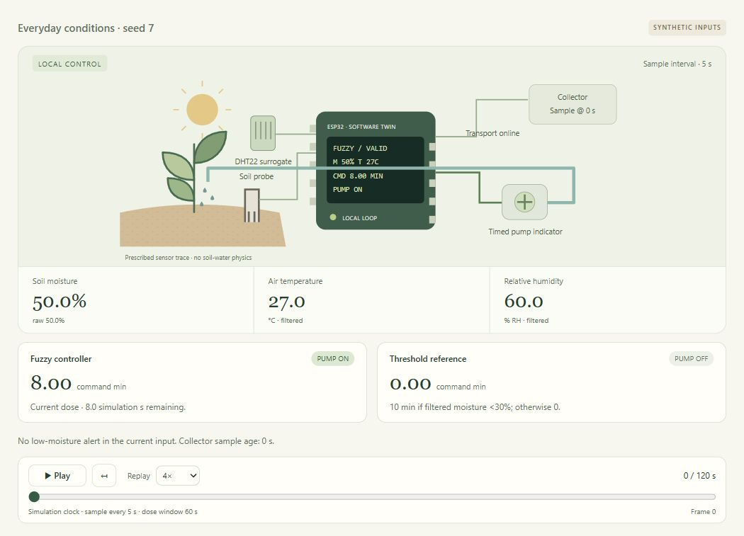
Figure 5: Normal synthetic input at 50% moisture, 27 °C and 60% RH produces an 8-minute fuzzy command and zero reference command.
Replay context: 0 / 120 s. Saved run: 20261024T190126038644Z-870a58f4. Raw trace and settings accompany the paper.
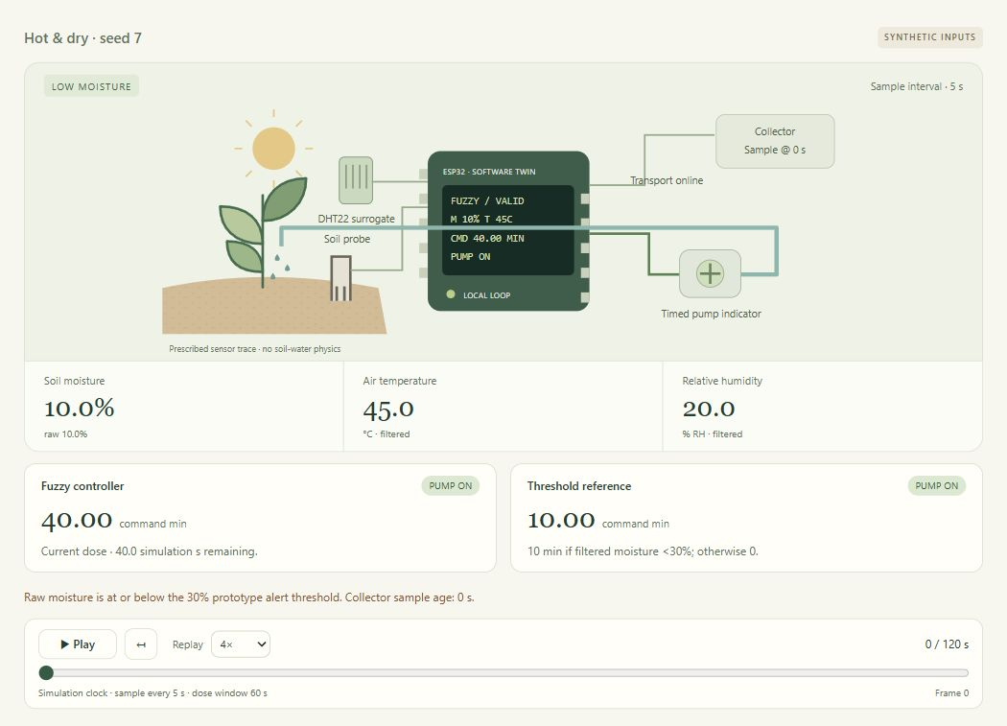
Figure 6: Dry and hot synthetic inputs produce a 40-minute fuzzy command and a 10-minute threshold-reference command.
Replay context: 0 / 120 s. Saved run: 20261024T190206689673Z-9a66375e. Raw trace and settings accompany the paper.
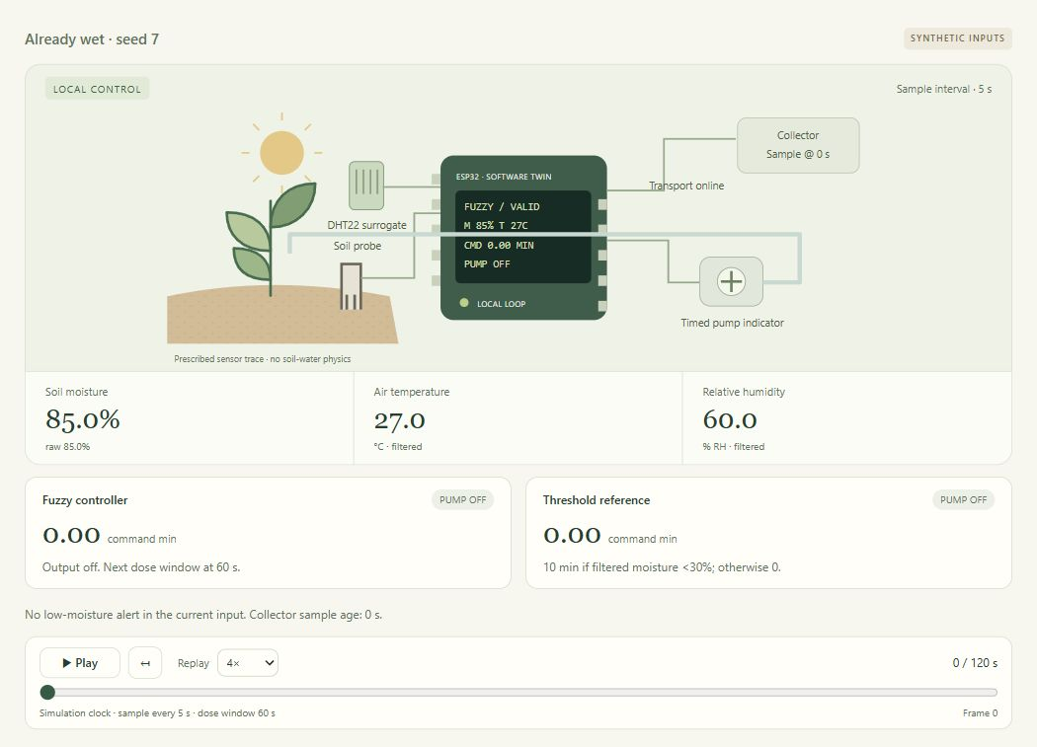
Figure 7: At 85% moisture both controllers issue zero and both logical pump outputs remain off.
Replay context: 0 / 120 s. Saved run: 20261024T190209514836Z-3f3b5a77. Raw trace and settings accompany the paper.
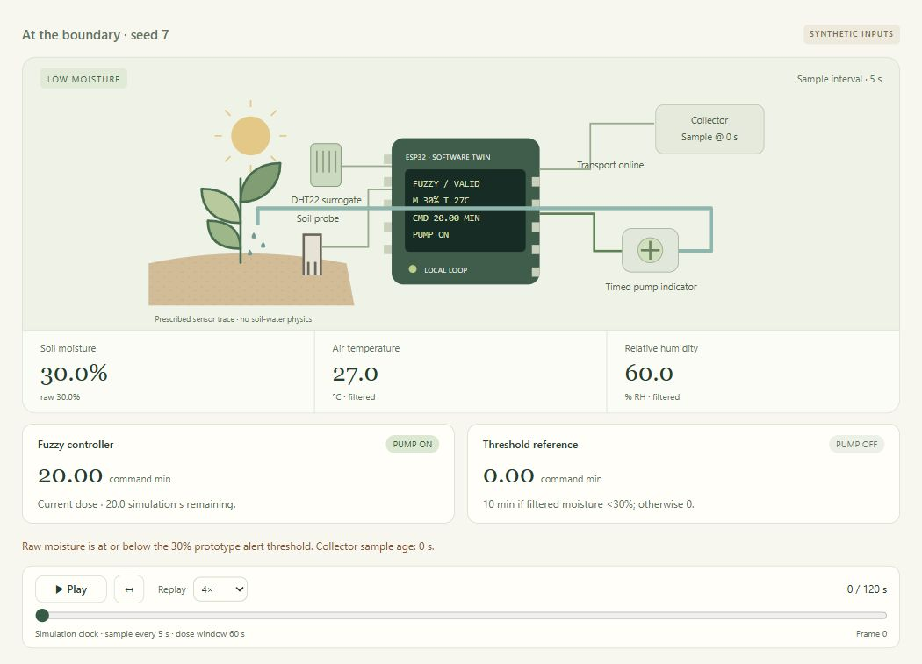
Figure 8: At exactly 30% moisture the inclusive low-moisture alert is active; the fuzzy command is 20 minutes while the strict threshold reference is zero.
Replay context: 0 / 120 s. Saved run: 20261024T190212418524Z-d9cae169. Raw trace and settings accompany the paper.
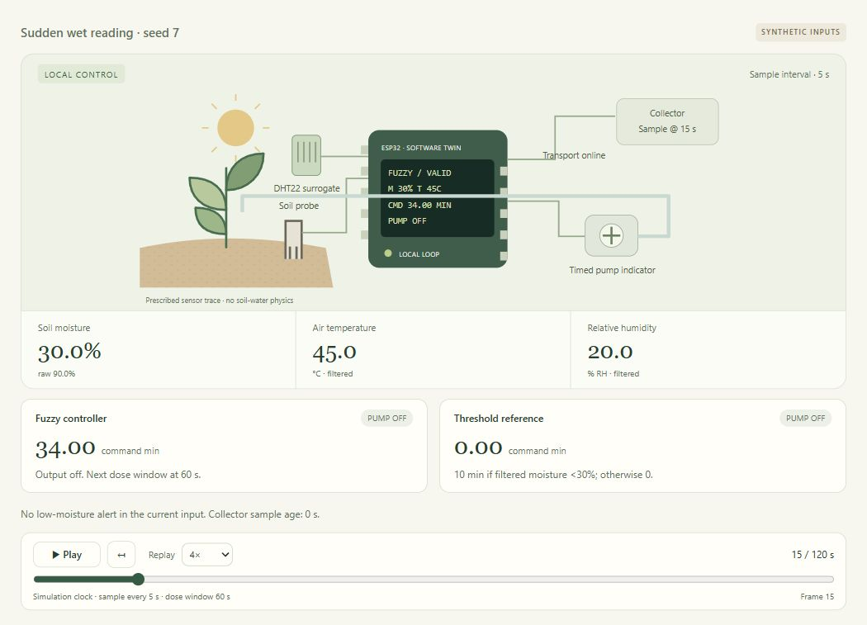
Figure 9: At 15 s raw moisture rises to 90%, while the moving average is 30%. The safety gate stops the pump despite a nonzero 34-minute fuzzy command.
Replay context: 15 / 120 s. Saved run: 20261024T190224597554Z-1e1fe932. Raw trace and settings accompany the paper.
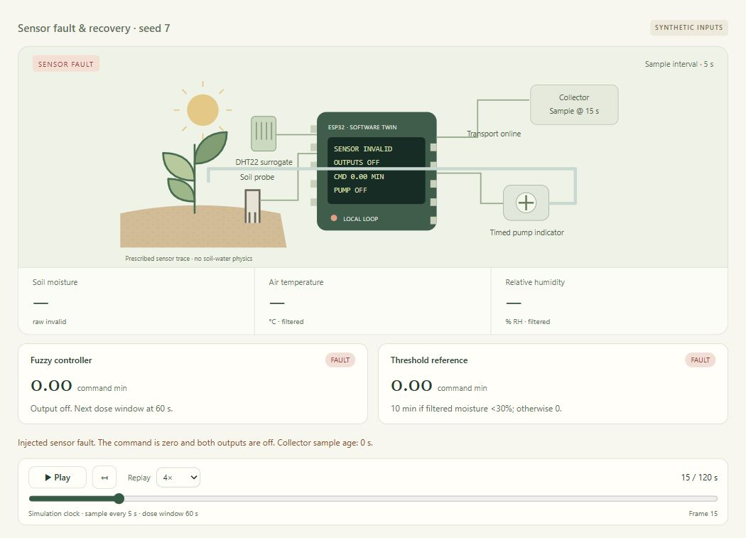
Figure 10: An injected fault produces unavailable sensor values, zero commands and both outputs off at 15 s.
Replay context: 15 / 120 s. Saved run: 20261024T190227823951Z-410c5b7b. Raw trace and settings accompany the paper.
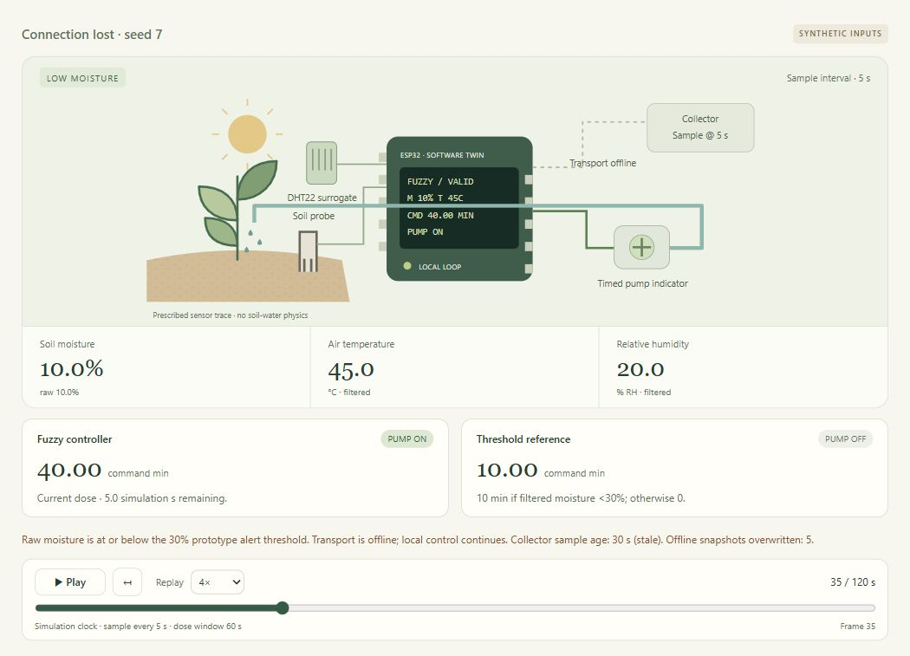
Figure 11: During the 10–40 s transport outage, local control remains active at 35 s while the collector holds its stale 5 s snapshot.
Replay context: 35 / 120 s. Saved run: 20261024T190230939923Z-d75c0339. Raw trace and settings accompany the paper.
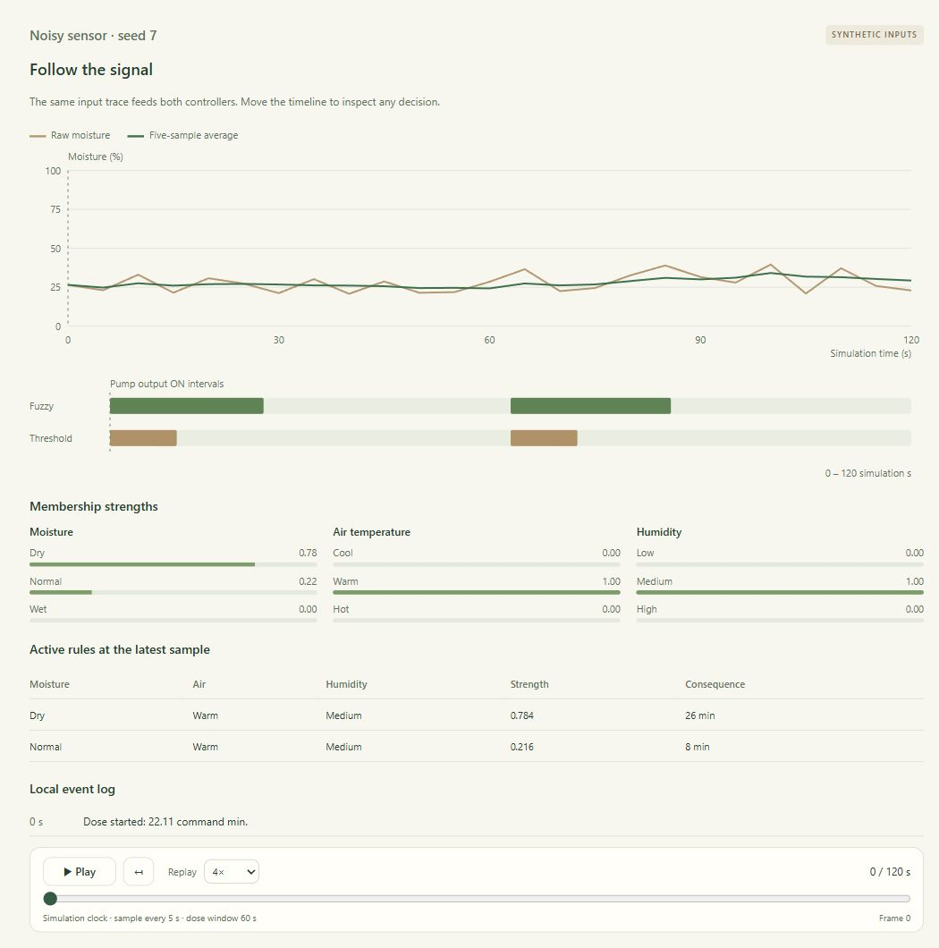
Figure 12: Seed-7 moisture noise and the five-sample average are plotted against the same simulation clock, with separate fuzzy and reference pump intervals.
Replay context: 0 / 120 s. Saved run: 20261024T190247956135Z-4d6f6805. Raw trace and settings accompany the paper.
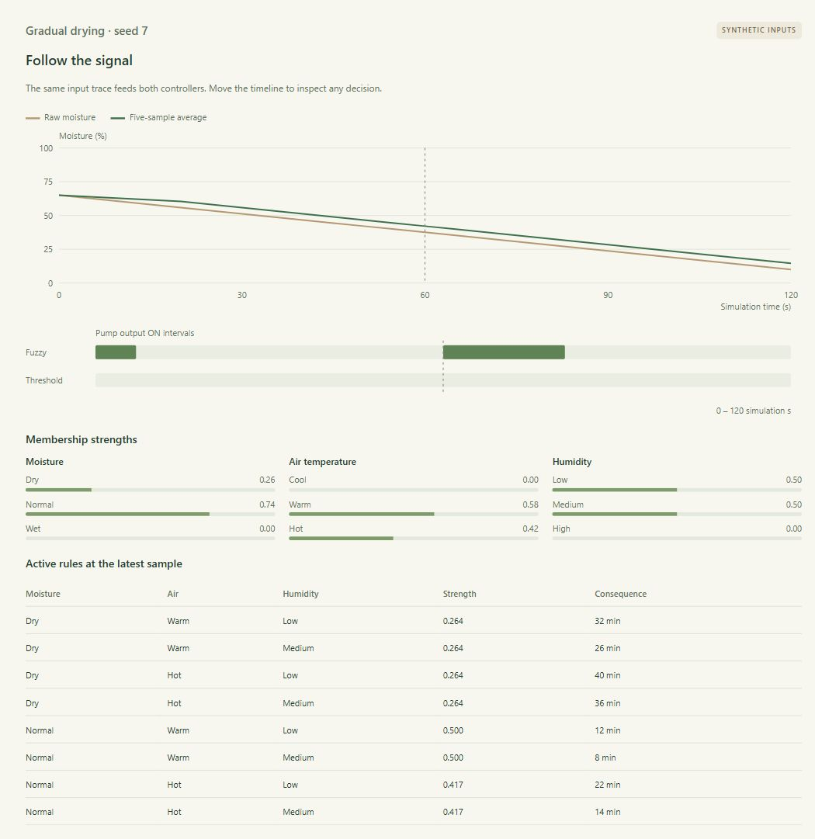
Figure 13: A prescribed moisture ramp from 65% to 10% drives both controllers; the plotted moisture is not affected by pump output.
Replay context: 60 / 120 s. Saved run: 20261024T190251842011Z-b53cba5d. Raw trace and settings accompany the paper.
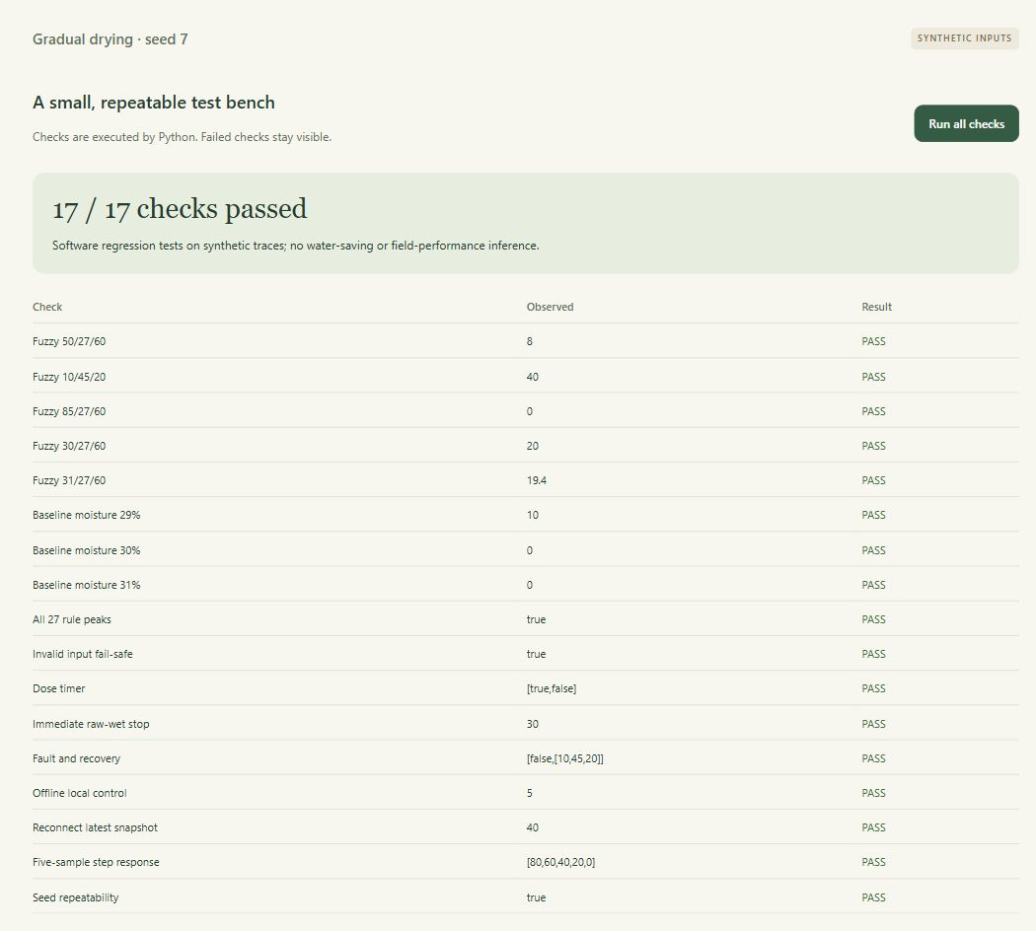
Figure 14: The Python test bench reports 17 of 17 executed checks passed, covering selected commands, rule peaks, boundaries, timer, filtering, faults and transport-surrogate behaviour.
Software regression bench: 17/17 checks passed. The screenshot shows executed checks; it is not a field-trial accuracy test.
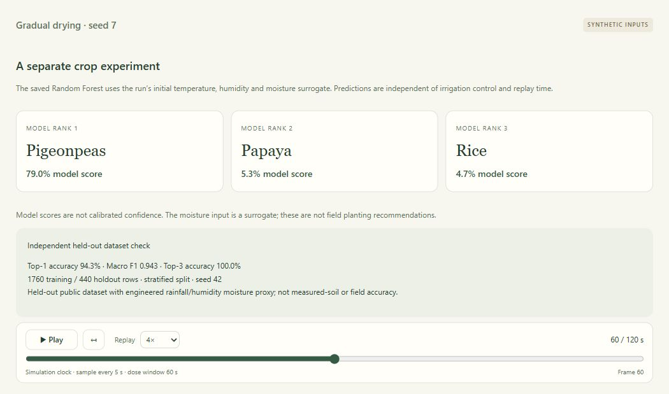
Figure 15: The separate crop experiment reports held-out dataset metrics from 1,760 training and 440 test records; this does not validate physical soil-moisture inputs.
Replay context: 60 / 120 s. Saved run: 20261024T190251842011Z-b53cba5d. Input conditions are listed in Table 6; the crop view uses initial inputs independently of replay.

Credit authorship contribution statement
Rishit Chaudhary: Conceptualization, Methodology, Firmware and Software Development, Fuzzy Logic Design, Testing, Writing – Original Draft.
Siddharth Verma: System Architecture, MQTT/Fog-Layer Implementation, Machine Learning Pipeline, Validation, Writing – Review & Editing.
Syamasudha Veeragandham: Supervision, Review, and Guidance.

Funding Statement
The authors declare that no funding, grants, or external support were received during the development of this work.

Declaration of competing interest
The authors declare that they have no known competing financial interests or personal relationships that could have appeared to influence the work reported in this paper.

Data Availability
The original application, dataset and legacy training scripts are available in the SmartAgri repository [15]. The dashboard revision is on branch codex/dashboard-design at commit c7f417ce9babd6409cf40ea0ba0ec6f664ba8819. The new simulator, firmware counterpart, source hashes, dataset hash, optional model metadata, nine scenario JSON/CSV traces, test outcomes and screenshot manifest accompany this paper in SmartAgri-Complete-Simulation.zip. The new simulator source and results in that package should be archived with any future publication; they are not represented as part of the earlier cited commit.
Repository: https://github.com/rizzit17/SmartAgri
The earlier Wokwi project is https://wokwi.com/projects/473619945395342337. It is a separate circuit counterpart; the browser screenshots and new numerical results originate from the accompanying Python simulation. No physical breadboard measurements or hydraulic dataset are included.

References
[1] K. G. Liakos, P. Busato, D. Moshou, S. Pearson, and D. Bochtis, “Machine Learning in Agriculture: A Review,” Sensors, vol. 18, no. 8, art. 2674, 2018. https://doi.org/10.3390/s18082674
[2] G. P. Pereira, M. Z. Chaari, and F. Daroge, “IoT-Enabled Smart Drip Irrigation System Using ESP32,” IoT, vol. 4, no. 3, pp. 221–243, 2023. https://doi.org/10.3390/iot4030012
[3] M. K. Senapaty, A. Ray, and N. Padhy, “A Decision Support System for Crop Recommendation Using Machine Learning Classification Algorithms,” Agriculture, vol. 14, no. 8, art. 1256, 2024. https://doi.org/10.3390/agriculture14081256
[4] P. Wijayakusuma, G. P. N. Hakim, and B. Li, “TerraGrow: Integrated platform for real time plant monitoring and automated watering system with IoT and fuzzy Sugeno Algorithm,” HardwareX, vol. 24, art. e00724, 2025. https://doi.org/10.1016/j.ohx.2025.e00724
[5] A. Cartolano, A. Cuzzocrea, and G. Pilato, “Analyzing and assessing explainable AI models for smart agriculture environments,” Multimedia Tools and Applications, vol. 83, no. 12, pp. 37225–37246, 2024. https://doi.org/10.1007/s11042-023-17978-z
[6] L. Breiman, “Random Forests,” Machine Learning, vol. 45, no. 1, pp. 5–32, 2001. https://doi.org/10.1023/A:1010933404324
[7] S. M. Lundberg and S.-I. Lee, “A Unified Approach to Interpreting Model Predictions,” Advances in Neural Information Processing Systems, vol. 30, pp. 4765–4774, 2017. https://proceedings.neurips.cc/paper/2017/hash/8a20a8621978632d76c43dfd28b67767-Abstract.html
[8] MathWorks, “Mamdani and Sugeno Fuzzy Inference Systems,” Fuzzy Logic Toolbox documentation. https://www.mathworks.com/help/fuzzy/types-of-fuzzy-inference-systems.html (accessed October 19, 2026).
[9] A. Banks and R. Gupta, Eds., MQTT Version 3.1.1, OASIS Standard, October 29, 2014. https://docs.oasis-open.org/mqtt/mqtt/v3.1.1/os/mqtt-v3.1.1-os.html
[10] Wokwi, “wokwi-dht22 Reference,” Wokwi Docs. https://docs.wokwi.com/parts/wokwi-dht22 (accessed October 19, 2026).
[11] Wokwi, “wokwi-ssd1306 Reference,” Wokwi Docs. https://docs.wokwi.com/parts/wokwi-ssd1306 (accessed October 19, 2026).
[12] Adafruit, “DHT11, DHT22 and AM2302 Sensors: Overview,” Adafruit Learning System. https://learn.adafruit.com/dht/overview (accessed October 19, 2026).
[13] scikit-learn developers, “Cross-validation: evaluating estimator performance,” scikit-learn User Guide. https://scikit-learn.org/stable/modules/cross_validation.html (accessed October 19, 2026).
[14] A. Ingle, “Crop Recommendation Dataset,” Kaggle, dataset landing page. https://www.kaggle.com/datasets/atharvaingle/crop-recommendation-dataset (accessed October 19, 2026).
[15] R. Chaudhary, SmartAgri, source repository, commit b1a2e3347ac4946798d9b213fda327a9c03aaf42, 2026. https://github.com/rizzit17/SmartAgri/tree/b1a2e3347ac4946798d9b213fda327a9c03aaf42 (accessed October 19, 2026).

